SHOPPING TREND ANALYSIS

1. Project Overview
The Shopping Trend Analysis project aims to understand customer purchasing behaviour, revenue patterns, and financial performance using a structured data analytics approach. The project integrates Excel, Python, SQL, and BI dashboards to transform raw shopping data into meaningful business insights. This end-to-end analysis supports data-driven decision-making related to marketing strategy, customer segmentation, inventory planning, and revenue optimization.
The prepared shopping trend dataset includes customer demographics, purchase details, payment methods, seasonal trends, review ratings, and subscription status. The analysis follows a complete data lifecycle: data cleaning, exploration, modelling, querying, and visualization.
2. Data Summary
The dataset consists of structured customer-level transactional data with the following key attributes:
- Customer ID and demographic details (Age, Gender, Location)
- Product category and season of purchase
- Purchase amount and payment method
- Promotional usage and subscription status
- Review ratings and previous purchase history
- 3,900 Rows and 18 Columns
The data was initially provided in Excel format and later integrated with Python (Pandas), SQL databases, and BI dashboards for advanced analysis.

3. Data Cleaning Using Excel
Excel was used as the first step for data preprocessing and validation:
- Removed duplicate records using Remove Duplicates
- Standardized column names and text formats
- Checked for missing or inconsistent values
- Converted numerical columns (purchase amount, ratings) into correct data types
- Ensured categorical consistency (e.g., Gender, Season, Payment Method)
Excel-based cleaning ensured that the dataset was reliable before moving into Python and SQL environments.

4. Exploratory Data Analysis Using Python
- Python (Pandas, NumPy, Matplotlib, Seaborn) was used for exploratory data analysis (EDA):
- Descriptive Statistics:
Mean: Average purchase amount and review rating
Median: Central tendency of spending behavior
Mode: Most common category, season, and payment method
Standard Deviation: Variability in purchase amounts
- Creating New Columns
- Missing Data Handling
- Checked missing values using isnull().sum()
- Applied appropriate strategies:
  - Numerical columns → mean/median imputation
  - Categorical columns → mode imputation
- Verified data integrity after handling missing values
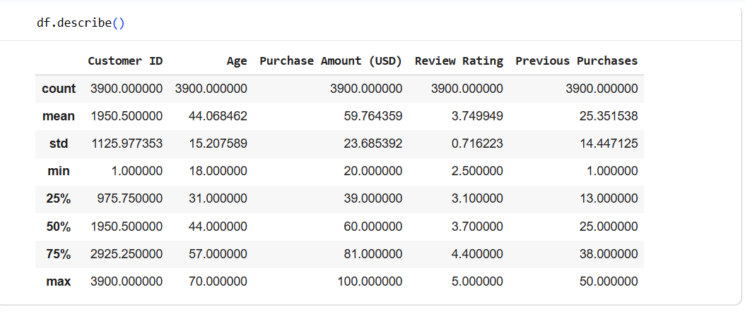
5. Model Score Checking and Linear Regression
A Linear Regression model was applied to predict purchase amount based on independent variables such as age, previous purchases, and review ratings.
Model Building
- Data split into training and testing sets
- Linear Regression model trained using Python
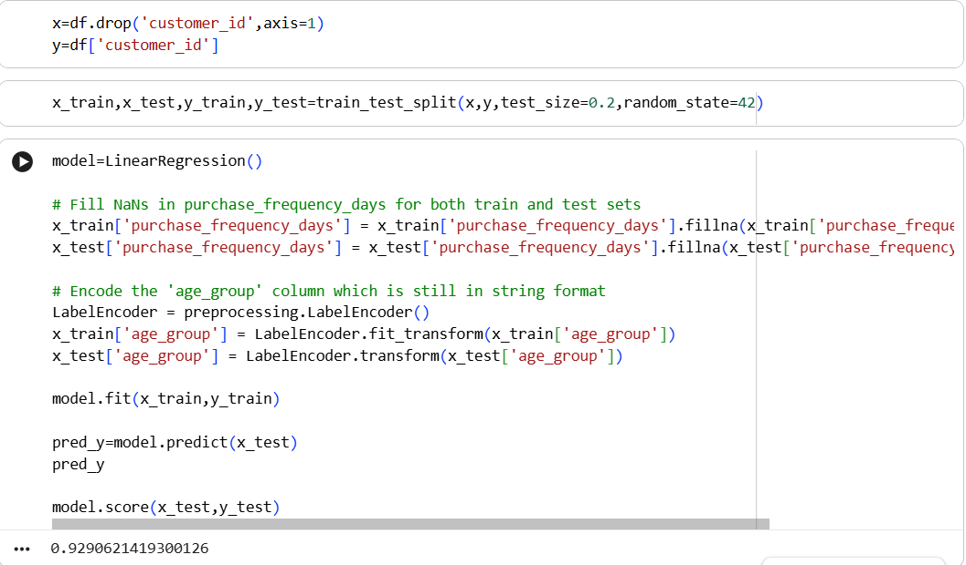
6. Data Analysis Using SQL
SQL was used for structured querying and business-level analysis after importing data into the database.
SQL Operations Performed
- CREATE DATABASE and CREATE TABLE
- INSERT, UPDATE, DELETE records
- ADD and DROP columns as required
- Aggregate functions (SUM, AVG, COUNT, MAX, MIN)
- GROUP BY and ORDER BY for trend analysis
Objective-Based SQL Analysis
A total of 19 objective SQL queries were implemented, including:
- Total and average revenue calculations
- Revenue by category, season, and payment method
- Customer segmentation and subscription analysis
- Identifying top revenue-generating customers
- Viewing tables and schema structure
These queries supported financial analysis and operational insights.
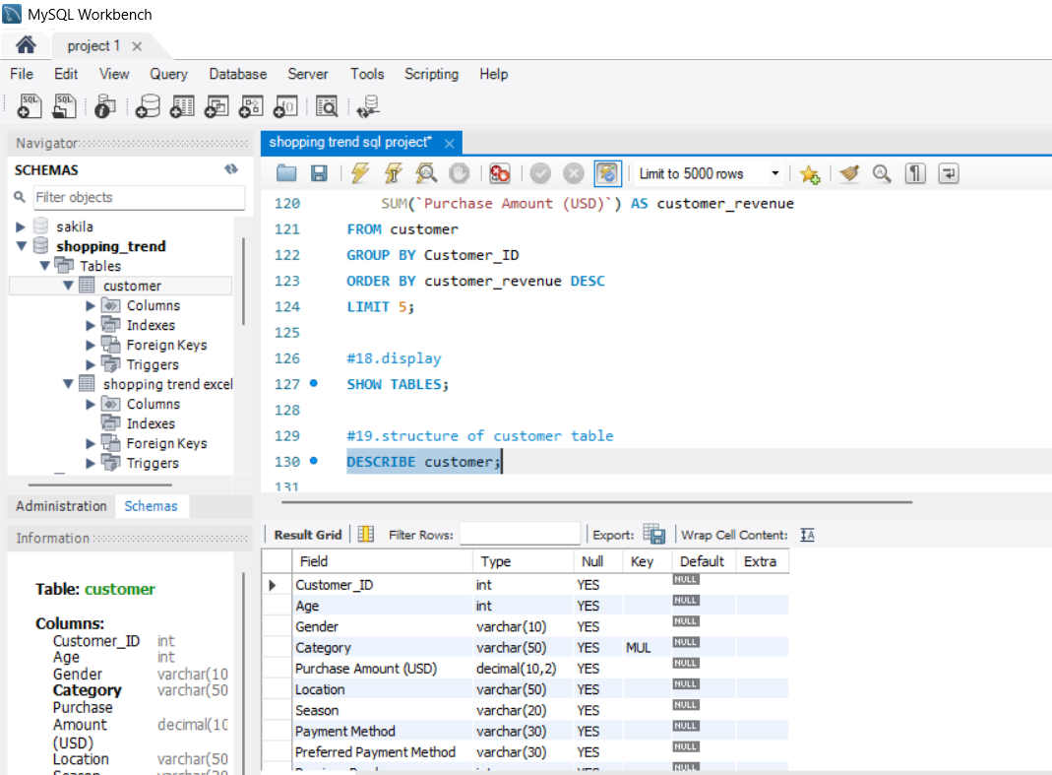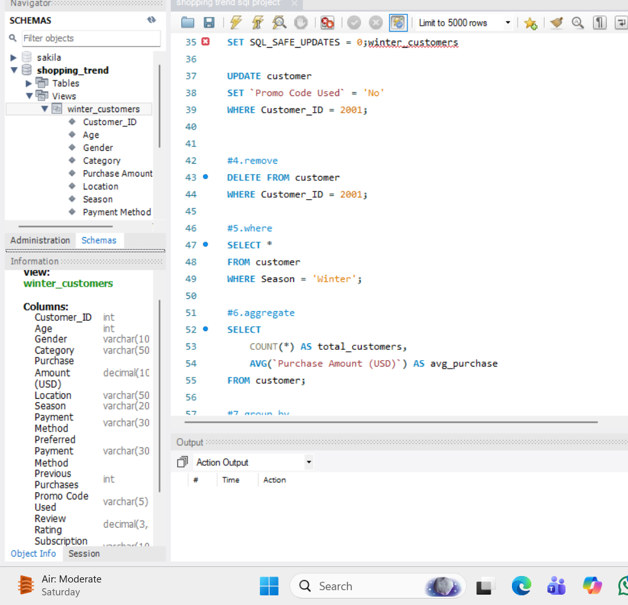
7. Dashboard Creation (3 Pages)
An interactive BI Dashboard was developed with three dedicated pages:
Page 1: Shopping Trend Dashboard
- Category-wise sales distribution
- Seasonal purchase trends
- Customer demographics overview
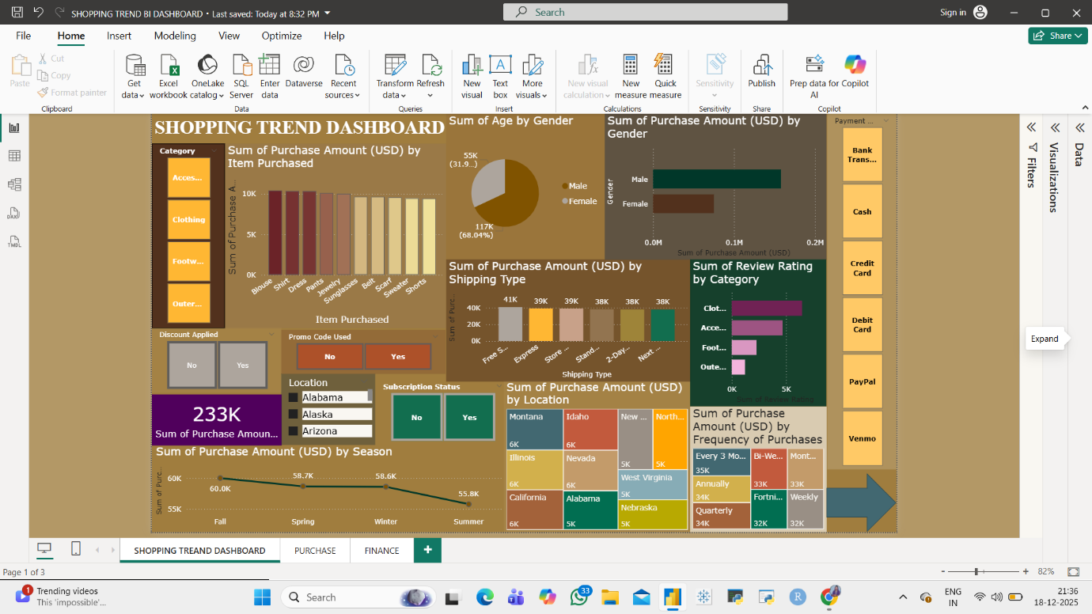
Page 2: Purchase Details Dashboard
- Individual customer purchase behavior
- Payment method analysis
- Promo code usage trends
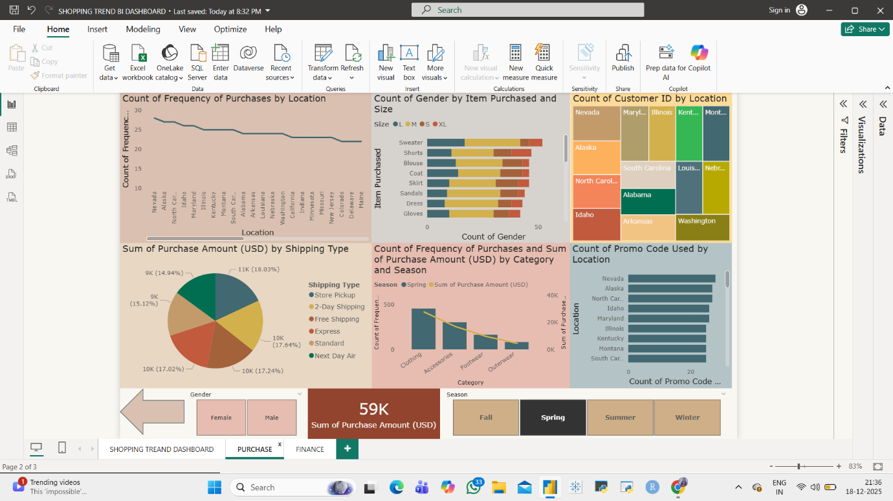
Page 3: Finance Details Dashboard
- Total revenue and average purchase value
- Revenue by subscription status
- High-value customer identification
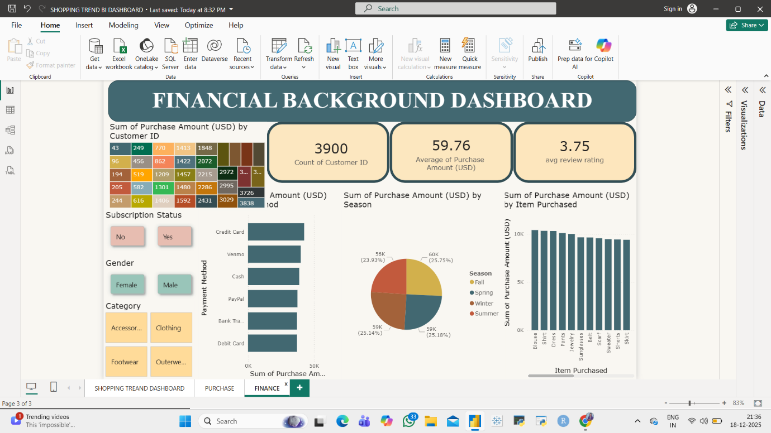
The dashboards provide a visual and intuitive understanding of the data for stakeholders.

8. Business Recommendations
Based on the analysis, the following recommendations are proposed:
- Focus marketing efforts on high-revenue categories and seasons
- Promote subscription plans to increase repeat purchases
- Optimize promo code strategies based on customer response
- Target high-value customers with personalized offers
- Improve inventory planning using seasonal demand trends

9. Conclusion
The Shopping Trend Analysis project demonstrates the effective use of Excel, Python, SQL, and BI tools to transform raw data into actionable insights. By combining statistical analysis, predictive modelling, structured querying, and interactive dashboards, the project provides strong business value and supports strategic decision-making.
This project highlights practical data analytics skills applicable to real-world retail and e-commerce environments.

Python: https://colab.research.google.com/drive/1zTJXiviqVFUP0iuTlZfLyg1oi7L7mQWe?usp=sharing
Power BI: https://colab.research.google.com/drive/1zTJXiviqVFUP0iuTlZfLyg1oi7L7mQWe?usp=sharing

